**Exercise No:9**

**ListofPlayers.js**

import React from 'react';

const ListOfPlayers = () => {

  const players = [

    { name: "Virat", score: 95 },

    { name: "Rohit", score: 88 },

    { name: "Dhoni", score: 70 },

    { name: "Jadeja", score: 67 },

    { name: "Pant", score: 92 },

    { name: "Bumrah", score: 85 },

    { name: "Shami", score: 78 },

    { name: "Gill", score: 65 },

    { name: "Ishan", score: 60 },

    { name: "Ashwin", score: 72 },

    { name: "Surya", score: 99 },

  ];

  const below70 = players.filter(player => player.score < 70);

  return (

    <div>

      <h2>All Players</h2>

      <ul>

        {players.map((player, index) => (

          <li key={index}>{player.name} - {player.score}</li>

        ))}

      </ul>

      <h2>Players with Score Below 70</h2>

      <ul>

        {below70.map((player, index) => (

          <li key={index}>{player.name} - {player.score}</li>

        ))}

      </ul>

    </div>

  );

};

export default ListOfPlayers;

**IndianPlayers.js**

import React from 'react';

const IndianPlayers = () => {

  const players = [

    "Virat", "Rohit", "Dhoni", "Jadeja", "Pant",

    "Bumrah", "Shami", "Gill", "Ishan", "Ashwin", "Surya"

  ];

  const oddTeam = players.filter((_, index) => index % 2 !== 0);

  const evenTeam = players.filter((_, index) => index % 2 === 0);

  const T20Players = ["Virat", "Rohit", "Pant"];

  const RanjiPlayers = ["Pujara", "Rahane", "Saha"];

  const mergedPlayers = [...T20Players, ...RanjiPlayers];

  return (

    <div>

      <h2>Odd Team Players</h2>

      <ul>

        {oddTeam.map((player, index) => (

          <li key={index}>{player}</li>

        ))}

      </ul>

      <h2>Even Team Players</h2>

      <ul>

        {evenTeam.map((player, index) => (

          <li key={index}>{player}</li>

        ))}

      </ul>

      <h2>Merged Team: T20 + Ranji Trophy Players</h2>

      <ul>

        {mergedPlayers.map((player, index) => (

          <li key={index}>{player}</li>

        ))}

      </ul>

    </div>

  );

};

export default IndianPlayers;

**App.js**

import React from "react";

import ListofPlayers from "./components/ListofPlayers";

import IndianPlayers from "./components/IndianPlayers";

function App() {

  const flag = false;

  return (

    <div className="App">

      <h1>Cricket App</h1>

      {flag ? <ListofPlayers /> : <IndianPlayers />}

    </div>

  );

}

export default App;

**Output:**

**Flag = false**

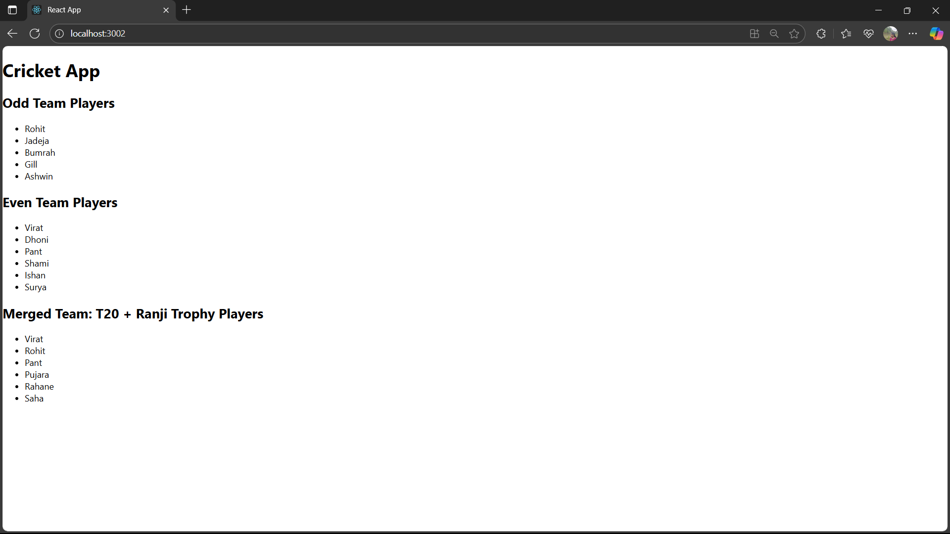

**Flag = true**

